Bahria University,


COURSE: CSL-210 OBJECT ORIENTED PROGRAMMING
TERM: SPRING 2023, CLASS: BSIT- 2 (B)

GYM MANAGEMENT SYSEM

Submitted By:

S.NO | Student Name | Enrollment #
02 | Abdul Wahab Aslam | 02-131222-132

Submitted to:

Engr.Mahawish/ Engr. Saniya Sarim

Signed : Remarks: Score: .

Table of Content

- Introduction…………………………………………………………Pg # 01
- OOP concepts used in project………………………………….…..Pg # 01
- UML class diagram…………………………………………………Pg # 02
- Features of Project…….……………………………………………Pg # 03
- Code………………………………………………………………….Pg # 04
- Interfaces…………………………………………………………….Pg # 07
- Conclusion…………………………………………………………...Pg # 10

Introduction:
A gym management system is a GUI based software that integrates and automates various aspects of running a gym, fitness, or yoga business. It enhances the customer experience and helps with marketing. The project aims to develop a comprehensive software solution that efficiently manages the operations of a gym or fitness center. The system automates various administrative tasks, simplifies member management, enhances scheduling and booking processes, streamlines billing and payment procedures, and provides insightful analytics for effective decision-making. This project report presents an overview of the Gym Management System, highlighting its key features, development process, challenges encountered, and future recommendations.

OOP Concepts:
By applying OOP concepts, the Gym Management System project achieves a modular and extensible design, with clear separation of concerns and code that is easier to understand, modify, and maintain. The following are some of the OOP concepts utilized in the project:

- Encapsulation:
In the Gym Management System, classes like Member, Payments etc. encapsulate relevant data fields and methods, ensuring data integrity and providing a clear interface for interacting with the system.
- Inheritance:
In the Gym Management System, inheritance can be observed in classes like Member and Update Member, which inherit common attributes and methods from a base class. This approach reduces code duplication and simplifies maintenance.
- Polymorphism:
In the Gym Management System, polymorphism can be seen in scenarios where different types of members (such as VIP, regular, and old) may perform certain common operations, but with specific implementations.
- Abstraction:
In the Gym Management System, abstraction is employed when designing classes like Membership and List of members, which provide high-level representations. This abstraction allows the system to manage complex data and operations more efficiently.
- Association and Composition:
In the Gym Management System, classes like Gym, Member, and Schedule are associated, indicating that a gym has members and schedules. Composition can be observed when classes like Gym contain objects of other classes, such as Members, Payment, representing their interdependence.

Class Diagram:

Features:
The features collectively aim to optimize gym operations, enhance member experience, and contribute to the overall success of the gym or fitness center. The key features of the Gym Management System are:
- Member Management:
Efficiently store and manage member information, including personal details, contact information, membership history, and attendance records. Simplify the registration process and provide a user-friendly interface for updating member profiles.
- Billing and Payments:
Automate membership fee calculations, generate invoices, and track payment history. Integrate with popular payment gateways for secure online transactions. Send automated payment reminders to ensure timely payments.
- Security and Access Control:
Implement robust security measures to protect member data and ensure secure transactions. Control access to sensitive information through user roles and permissions. Implement measures to safeguard against unauthorized access.
- Customization and Branding:
Allow gym owners to customize the system's branding, including logos, colors, and themes, to maintain a consistent brand identity. Tailor the system to meet specific business requirements and adapt to unique gym offerings or programs.
Code:
Main:
Interfaces:
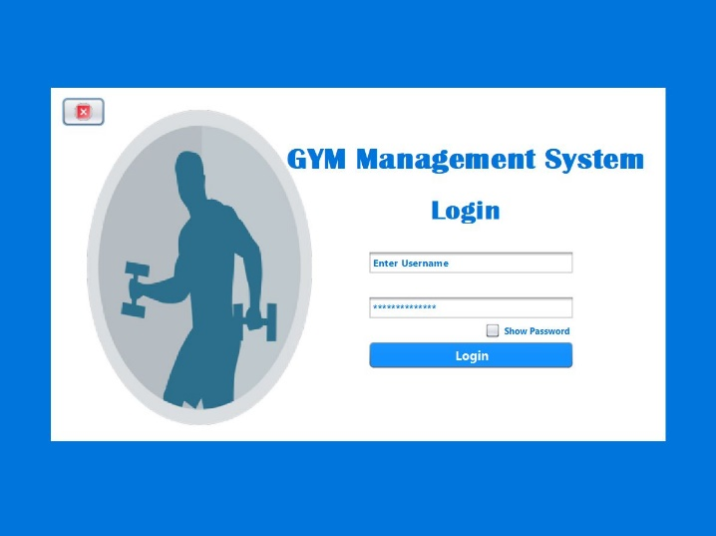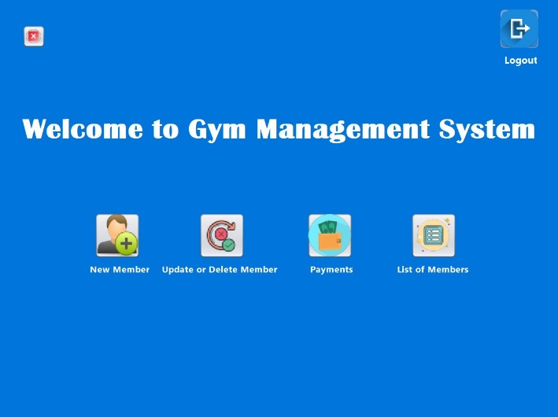

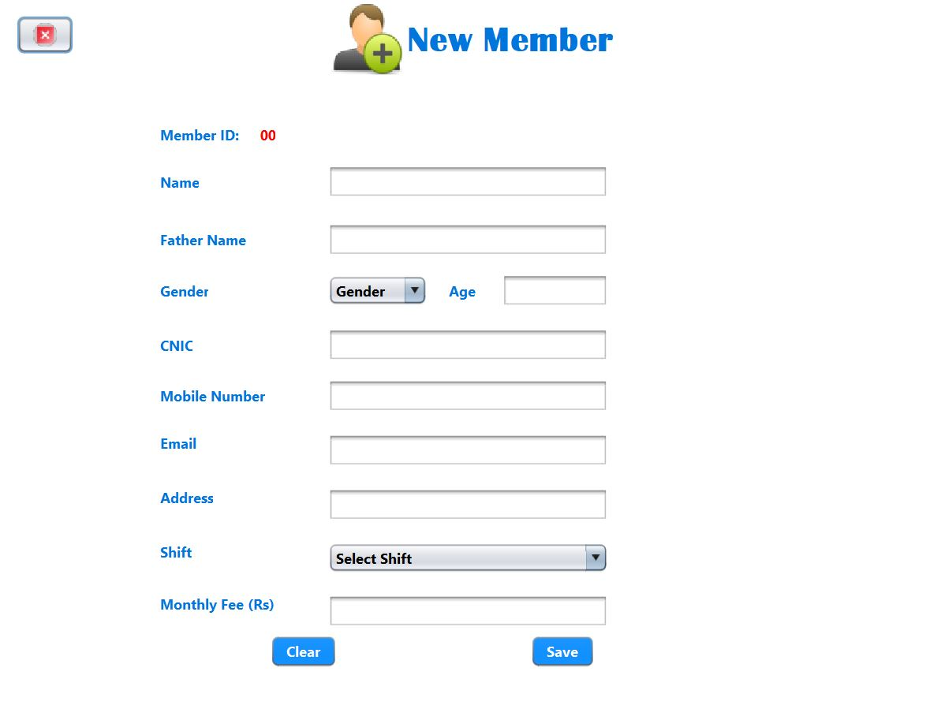
.
Conclusion:
The Gym Management System project has developed a comprehensive software solution for efficient gym and fitness center management. By implementing key Object-Oriented Programming (OOP) concepts, the project ensures a modular and maintainable design. The system simplifies member management, facilitates billing and payments, provides valuable reporting and analytics. With future recommendations such as biometric authentication and mobile application development, the system can continue to evolve and meet the changing needs of the fitness industry. Overall, the project successfully achieves its objective of optimizing gym operations and enhancing member experience.

